Report File
Assignment 3 Data Structures
Adeeba Nizam
Q1)
This project demonstrates the implementation of a generic Queue data structure in C++ using a template class. The goal is to build a queue that works for any data type and supports all standard queue operations. This project also includes a custom function move_to_rear() that mimics rotation of the queue using only allowed operations. The queue uses a circular array internally, meaning that the rear of the queue wraps around to the front when it reaches the end of the array. This ensures efficient memory use and avoids shifting elements.
- push()
- pop()
- front()
- size()
- empty()
- move_to_rear() (custom function)
The project is split into:
- Queue.h (header file with declarations)
- Queue.cpp (template implementation)
- main.cpp (driver program demonstrating queue operations)
How to Compile and Run:
Follow the steps below to compile and run the program.

Using g++ (Linux/Mac/Windows MinGW)
g++ main.cpp -o queue_program
./queue_program

Using Visual Studio Code
- Open the folder containing all three files (Queue.h, Queue.cpp, main.cpp).
- Install the C/C++ extension.
- Create a build task or simply press Run → Run Without Debugging.

Using Visual Studio (Windows)
- Create a new C++ Console Application.
- Add Queue.h, Queue.cpp, and main.cpp to the project.
- Build and run using Ctrl + F5.
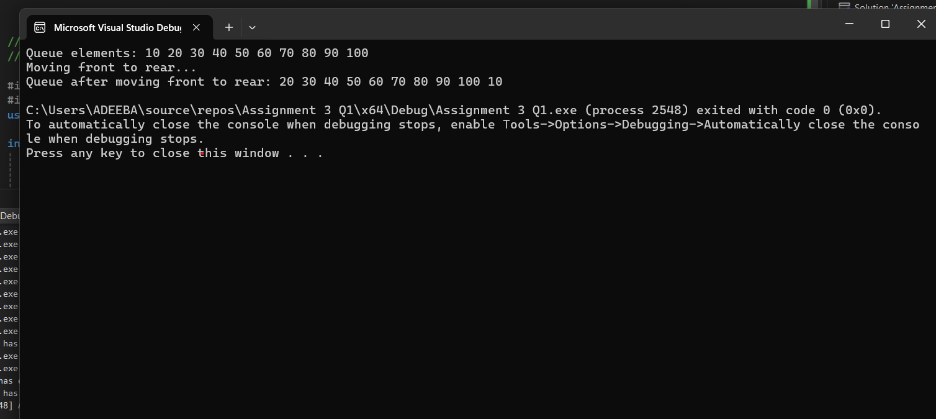

File Structure
project-folder/
│
├── Queue.h
├── Queue.cpp
├── main.cpp
└── README.md (this report)

The queue uses a circular array for efficient rotation. move_to_rear() uses only push, front, and pop, as required.

